**Saving Tarunas Police Post – A Record of Bunun Cultural Legacy along the Batongguan Traversing Trail (1)**

Located at the east of the Yushan National Park, the Lakulaku River drainage basic has been the habitat of the ancestors of Isbukun and Takibanuaz of the east Bunun tribe. Since the establishment of the Yushan National Park Administration Office (referred to as the Office), it has conducted investigations and research on the humanistic resources in that area. It entrusted Dr. Huang Chun-Ming of the Department of Architecture, Chung Yuan Christian University and others to conduct the projects “A Survey of Old Bunun Tribes at the Lakulaku River Watershed” from 1998 to 1999 and the “Plan on the Preservation and Restoration of Historical Sites in the Lakulaku River Watershed” from 1998 to 2000, it was discovered that there are 55 historic Bunun architectural clusters and architectural relics from the Japanese Taiwan era along the Batongguan Traversing Trail. Among them, the Tarunas Police Post and Fort Vavanu are valuable ruins of humanistic history along the Batongguan Traversing Trail. The office of the Tarunas Police Post still retains the architectural structure and appearance of that time. They are important historical relics for the study of architecture form and method of the police post during the Japanese rule. In addition, along the Batongguan Traversing Trail, ruins of the Bunun tribe are scattered around, providing evidence for the inhabitation of the Bunun people in eastern Taiwan.

Now people appealed that the roof of the Tarunas Police Post was damaged by wind toppled trees. To protect the important humanistic and historical relics and to prevent the police post being damaged by rain and typhoon and saving it from collapse and other irreversible damages, the Office scheduled to save the Tarunas Police Post from February 18 to 28, 2021. The Tarunas Police Post is located on the branch of the Masisan in a remote area. It takes about 10 days of travel to and from the hiking gate to the police post. In addition, they had to cross the landslide and rivers. Therefore, in this trip in addition to the staff of the Office, professional tree climbing teams were invited to help preserve the historic remains. Nevertheless, the professional tree climbing equipment weighs 117kg, including 17 tools. Therefore, the Office also hired people from the Hualien Zhuosi Township Mountaineering Association for help, and a total of 21 people were included in this mission. In addition to clearing wind toppled trees, the mission will also record the current conditions of the preservation of the cultural relics in the police post for the reference of management and to serve as the basic information for the preservation of cultural assets and the sketching and survey of the location in the future. Moreover, the Hualien Forest District Office, Forestry Bureau will also send its staff to conduct the investigation of lumbering ruins there.

In this mission, 4 indigenous people living in Hualien Zhuosi Township will also go to the destination with the team to record the ruins of historic Bunun houses and explore the roots of Bunun culture. The Office expressed that the works in this Tarunas Police Post rescue mission has been evaluated carefully, with the collaboration of the neighboring tribes, professionals, human resources, and materials from the private sector. It would like to advocate that when people enter the national park and hike along the Batongguan Traversing Trail, they should treasure the precious historical ruins and cultural relics. When hiking there, other than taking photos, visitors should not take anything away to provide the descendants the opportunities of witnessing and experiencing their culture.

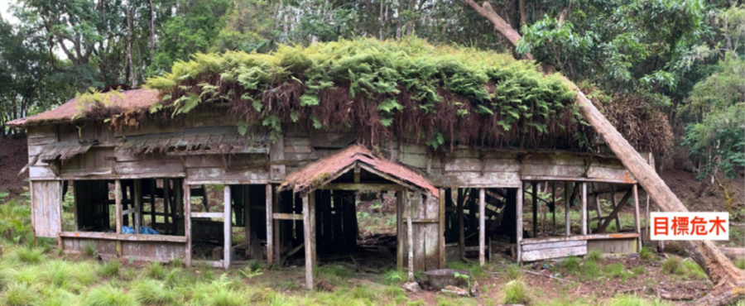

Photo 1: Wind toppled trees fallen on the roof of the Tarunas Police Post (Photo at the courtesy of Arbor Soul Ltd.)

Photo 2: In the direction from Masisan River to Tonkatsu Police Post, there are many Bunun houses.

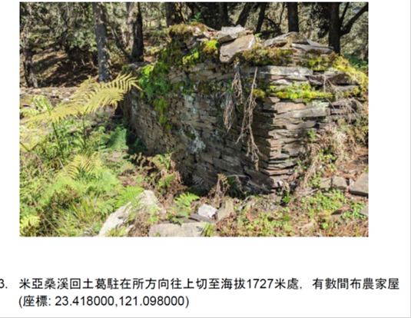

Photo 3: Along the ridge from Tarunas Police Post to Masisan River, there are many Bunun houses.

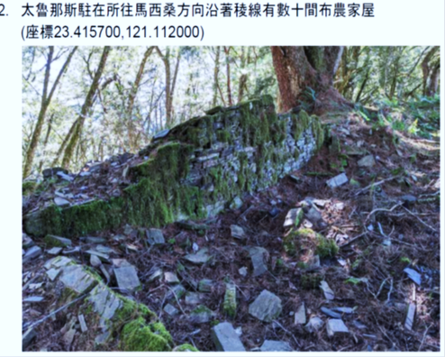

(Photo 2 and Photo 3 at the courtesy of Ms. Li Hui-Ying)

Photo 4: The team formed by the Office, Hualien Forest District Office of the Forestry Bureau, Hualien Zhuosi Township Mountaineering Association and Arbor Soul Ltd. preparing to depart at Maravi.

